Mini Task 1: Theoretical Part

# 1. Blockchain Basics

Blockchain is a decentralized, distributed digital ledger that records transactions across many computers. It ensures data integrity and transparency without the need for a central authority. Each record or 'block' contains a list of transactions and is linked to the previous block through a cryptographic hash, creating an immutable chain. This structure makes it highly secure against tampering and fraud. Blockchains are most commonly associated with cryptocurrencies, but their application spans many industries due to their trustless and transparent nature.

Real-life use cases:

* • Supply Chain Management
* • Digital Identity Verification

# 2. Block Anatomy

A typical block contains the following elements:

* • Data
* • Previous Hash
* • Timestamp
* • Nonce
* • Merkle Root

Merkle Root is a single hash value representing the combined hash of all transactions in the block. It helps verify data integrity efficiently. For example, in a block with 4 transactions (T1, T2, T3, T4), T1 and T2 are hashed together to form H1, T3 and T4 form H2, and then H1 and H2 are hashed to form the Merkle Root. If any transaction changes, the root changes, flagging the tampering.

# 3. Consensus Conceptualization

* • Proof of Work (PoW):

PoW is a consensus mechanism where participants (miners) solve complex mathematical problems to add blocks. It ensures security but requires significant energy due to computational demands.

* • Proof of Stake (PoS):

PoS replaces mining with staking. Validators are selected based on the number of coins they hold and are willing to lock up as a stake. It is more energy-efficient than PoW.

* • Delegated Proof of Stake (DPoS):

DPoS involves stakeholders voting for delegates to validate transactions and maintain the blockchain. It is democratic and allows faster block production, but can be less decentralized.

# Appendix: Diagrams

Chained Blocks Structure:

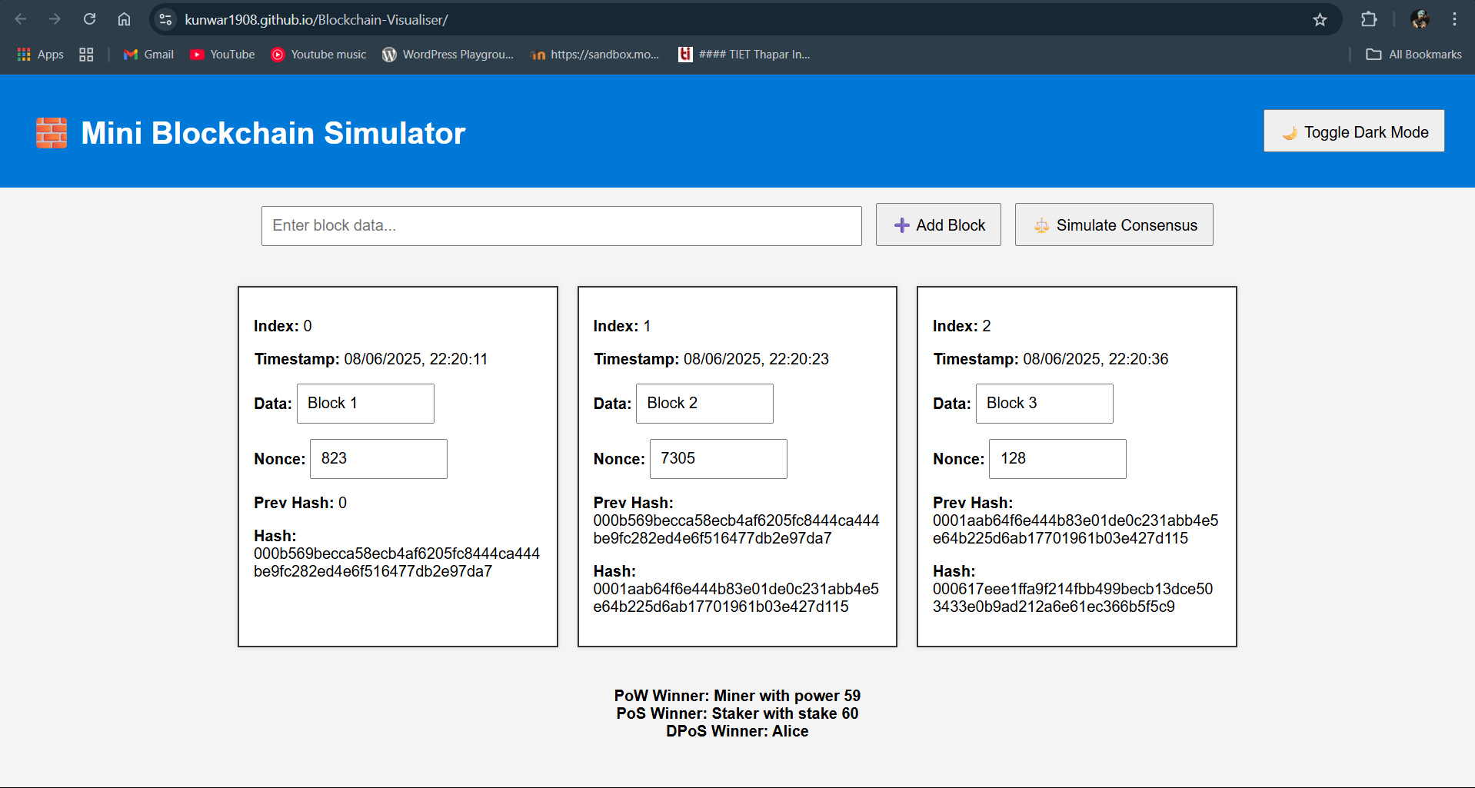

<https://kunwar1908.github.io/Blockchain-Visualiser/>